(Approx. 385 words)

Gnome Maps
by Cal Esneault, Co-Editor, Workshop and SIG leader
Cajun Clickers Computer Club
April 2018 issue, Cajun Clickers Computer News
www.clickers.org
tsa70785 (at) gmail.com

Anyone who has used Google to search for an item would not be surprised to soon receive numerous advertisements for similar merchandise. For privacy reasons, you could switch to a less invasive search engine, such as DuckDuckGo. To minimize tracking of your travels, an alternative to Google Maps is Gnome Maps (it is based on information from OpenStreetMap). I downloaded the software for my Linux Mint system directly from the Mint Software Manager. It was installed in the "Accessories" group under the "Maps" name.

Below is a screenshot of a section of Baton Rouge as displayed by the Gnome Maps program. Zooming and scrolling around was very smooth. Details emerged as you drill down to smaller and smaller areas. It has an icon which will generate a side panel where you can enter end points of your travel to get a preferred route. It gives the estimated time and distance as well as step-by-step route points. I did not see an easy way to print out the route by itself, so you either have to write it down or crop the path instructions to other software for printing.

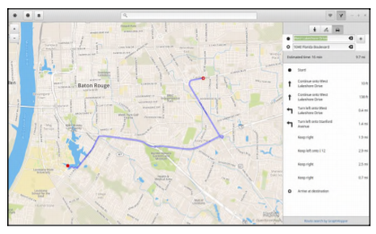

You have three choices by which it will choose a route (done by graphhopper): driving, bicycling, or walking. The above route was for driving from LSU to the Cajun Clickers, so it chose a route using the Interstate. When I switched to a route for a bicycle, it gave the map below. This was a less dangerous route, but I think I would make a few adjustments.

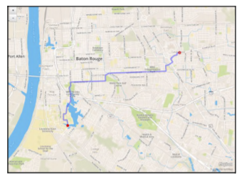
Gnome Maps also gives you the option to view the maps in photographic view (see below for the area around our club site).
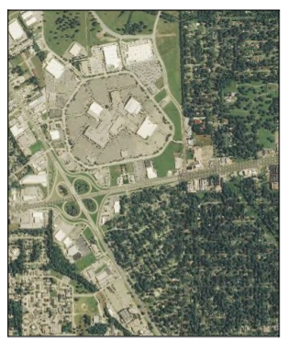
Overall, I found Gnome Maps to be a very simple and clean program that did exactly what I wanted without having to go through Google. Although the OpenStreetMaps application has more options, I found it had many extra features which seemed to make it less responsive than Gnome Maps. Since Google maps are tagged, use of either Gnome Maps or OpenStreetMaps gets you away from issues if you distribute directions to the public and if you are unsure of "fair use" limitations.

